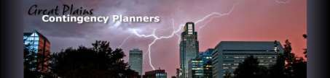

Great Plains Contingency Planners (GPCP) Seminar & Vendor Expo
Wednesday, August 30, 2023
8:30 a.m. to 4:15 p.m.
University of Nebraska at Omaha
Agenda

8:00 am – 8:30 am Registration, Networking, and Coffee 8:30 am – 8:40 am Welcome and Housekeeping Information 8:40 am – 9:00 am Demo – TierPoint (Rod Peterson)
9:05 am – 10:05 am Douglas County Emergency Management Agency – Whitney Shipley (Assistant Director)

10:05 am – 10:25 am Demo – Fusion (Jonathan Hartmann)

10:25 am – 10:40 am Morning Break

10:40 am – 11:55 am Tabletop Exercise - Paul Lambert (Ripcord)

11:55 am –12:55 pm Lunch

12:55 pm – 1:55 pm Crisis Communications – The Good, The Bad, The Ugly
Dr. Steven Goldman - MIT

1:55 pm – 2:15 pm Demo – CGH Group (Crisis & Situational Consulting Service)

2:20 pm – 2:40 pm Demo – Ripcord (Paul Lambert)

2:40 pm – 2:55pm Networking Break/Afternoon Snack

3:00 pm – 4:00 pm Active Threat - Officer Jason Cvitanov (OPD)

4:00 pm – 4:15 pm Closing remarks and door prizes

4:30 pm – 5:30 pm Networking Happy Hour – Legends Patio (6920 Pacific St.)

Thank you to our all our vendors!

